TUTORIAL Biomedical Instrumentation EE4904
PART II Session 3: Pressure, Force, Flow, Temperature

Question 1. If blood flowing in a vessel with a radius of 2 mm cuts a magnetic field with flux density B = 0.1 T, and the blood volume flow rate is 10 cm³/s, what is the electric potential that can be detected across the vessel.

Question 2. The resistance of a semiconductor thermistor is a function in the absolute temperature in Kelvin (K) expressed as
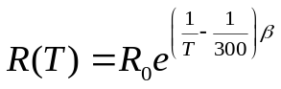.
It is known that β = 3150 and R(300) = 1600 Ω. Sketch a plot of the thermistor resistance as a function in T and find the sensitivity of the thermistor at T = 300 K and T = 310 K, respectively.

